Excerpt from “Manners and Customs of the Bible” by James M. Freeman ISBN: 0-88270-022-7

Genesis.] BIBLE MANNERS AND CUSTOMS. [Pg.] 29

35. NOSE - JEWELS – BRACELETS

XXIV, 22. It came to pass, as the camels had done drinking, that the man took a golden ear-ring of half a shekel weight, and two bracelets for her hands of ten shekels weight of gold.

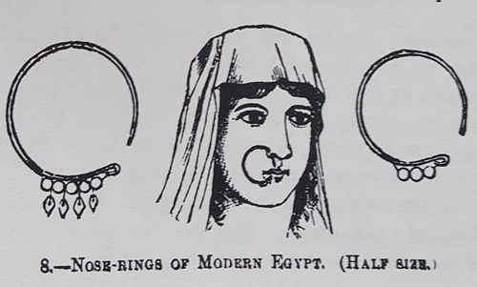
1. The “ear-ring” here spoken of (nezem) is more properly a nose-ring. The servant says, (verse 47,) “I put the ear-ring upon her face.” The present of a single ear-ring would be strange; to put it on the face would be stranger still. Nose-jewels are referred to Prov. Xi, 22, Isa. Iii, 21, and Ezek. Xvi, 12, where for “forehead” in the text the margin has “nose.”

[Pg.] 30 BIBLE MANNERS AND CUSTOMS. [Genesis.

The nose-ring is made generally of silver or gold, but sometimes of coral, mother-of-pearl, or even of horn, according to the taste or means of the wearer. This curious ornament varies considerably in size and thickness. The metal rings are usually from one inch to one inch and a half in diameter, and sometimes are as large as three inches. Beads, coral, or jewels, are strung upon them. They are usually hung from the right nostril, though sometimes from the left, and occasionally they are suspended from the middle filament of the nose. In India, according to Roberts, the nose-jewels are of different shapes, resembling a swan, a serpent, or a flower. Anderson saw them in Egypt, made of brass, but worn only by women of the lower class. Graham says that in Syria as well as in Egypt, these ornaments are not worn among the respectable classes of society, but are found among the Africans and slaves; so that the fashion seems to have changed since Rebekah’s day, and since the time when Isaiah wrote.

2. The weight of the nose-jewel given to Rebekah (a half shekel) was nearly a quarter of an ounce, troy.

3. Bracelets are almost universally worn by women in the East. They are sometimes made of gold, sometimes of mother-of-pearl, but usually of silver. The poorer woman wear them made of plated steel, horn, brass, copper, and occasionally nothing but simple strings of beads. The arms are sometimes crowded with them from wrist to elbow.

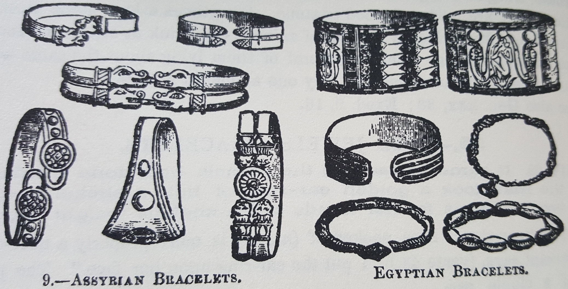

They are sometimes flat, but more frequently round or semicircular, and are often made hollow to give, by their bulk, the appearance of greater weight. Bracelets (tsemedim) are also referred to in Num. Xxxi, 50; Ezek. Xvi, 11; xxiii, 42. The other passages in which “bracelets” occur have different words in the original, which will be explained under the several texts where they are used.

4. The weight of the bracelets presented to Rebekah (ten shekels) was over four and a half ounces. They are sometimes worn heavier than this, so as to seem more like manacles than bracelets.

End of excerpt from “Manners and Customs of the Bible”
The information following this paragraph is for reference only (eg. where each word appears in the Bible) and I cannot guarantee it is free from error. The reader is highly encouraged to read each verse pertaining to the word(s) in question (eg. earring/earrings) and its context (the verses/chapter[s] surrounding it) carefully and to thoughtfully and prayerfully obtain the intended meaning (Psalm 25:9, Proverbs 2:6, James 1:5, 1 Corinthians 2:14).

NOTE: In Genesis 24:22, 30, 47 (Abraham’s eldest servant gives earrings and bracelets to Rebekah) the English word “earring” was translated from the Hebrew word “Neh’zem” (H5141).

The following is an exhaustive list of the three Hebrew words in the KJV OT that were translated to “earring/earrings”.

Strongs number | Hebrew | English | Verses
H5141 | נֶזֶם (neh’zem) | earring/earrings (14x) | Genesis 24:22, 30, 47; 35:4  Exodus 32:2, 3; 35:22  Judges 8:24, 25, 26  Job 42:11  Proverbs 25:12  Ezekiel 16:12  Hosea 2:13
 |  | jewel/jewels (5x) | Exodus 35:22  Proverbs 11:22  Isaiah 3:21  Ezekiel 16:12  Hosea 2:13
H5694 | עָגִיל (aw-gheel’) | Earrings (2x) | Numbers 31:50  Ezekiel 16:12
H3908 | לַחַשׁ (lakh’-ash) | Earrings | Isaiah 3:20
 |  | Enchantment | Ecclesiastes 10:11
 |  | Orator | Isaiah 3:3
 |  | Prayer | Isaiah 26:16
 |  | Charmed | Jeremiah 8:17

Strongs definition (ISBN: 0-529-06334-4)
H5141. נֶזֶם nezem, neh'-zem; from an unused root of uncertain meaning; a nose-ring:—earring, jewel.

